

SUPERIOR UNIVERSITY LAHORE

GOLD CAMPUS

**NAME:** MUHAMMAD MOIZ RAZA

**ROLL NO:** SU92-BSAIM-F24-**061**

**PROGRAM:** ARTIFICIAL INTELLIGENCE

**SEMESTER:** 3rd SEMESTER

**SECTION:** BSAI-3A

**SUBJECT:** ARTIFICIAL INTELLIGENCE

**Submission Title:** LAB TASK-1

* TO-DO-LIST

**Submitted To: Sir RASHIK ALI**

**LAB TASK 1**

**TASK:** TO-DO-LIST

## **Why We Write This Code?**

We write this program to create a simple **to-do list manager** that helps us keep track of our daily tasks. In real life, people often forget things like homework, shopping, or meetings. A to-do list makes life more organized by allowing us to note tasks, complete them, and remove them when done. This program is basically a **digital helper** where you can add new tasks, remove completed ones, and view your current list anytime. At the same time, it is also a good way to practice programming skills such as working with classes, lists, loops, and user input in Python.

## **How the Code Works**

When the program starts, it shows a menu with four options: add task, remove task, show tasks, or quit. If you choose to add a task, the program asks you for the task name and then stores it. If you choose to remove a task, it checks whether the task is in the list and removes it if found, otherwise it shows “Task not found.” If you choose to show tasks, the program asks for a number and shows the task at that position in the list, but if the number is larger than the list length, it warns you that the index is out of range. Finally, if you choose to quit, the program ends with a goodbye message. In short, the program acts like a **personal assistant** that waits for your instructions and helps you manage your tasks one by one.

## **OUTPUTS:**

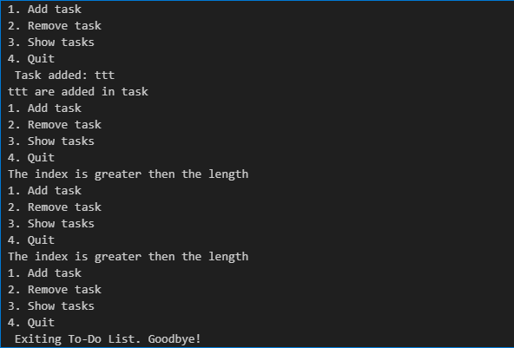

THE END